Visualizations on the Complex Plane
Jan Hubička, Prague (Czech Republic)
Zoltán Kovács, Szeged (Hungary)
Zoltán Kovács, Nyíregyháza (Hungary)
Abstract: We demonstrate the power of the domain coloring method using the color wheel in visualizing complex functions. A new approach for the real-time presentation of zooming in for complex variable functions is also introduced. Both didactical and technical details give a wide overview for this important novel topic in computer-aided mathematical visualization.
ZDM-Classification: I85, H65.
1 Introduction
Thinking in complex arithmetic and complex functions, besides real variable mathematics, opens up possibilities both in teaching and research. From the teacher's view, modern men of the future need extended mind not only in mathematical thinking, but in answering “every day challenges”. If mathematics may be a kind of art, not only calculations, humane minded people may move their interests towards such mathematics. That's why non-standard geometry is so popular among not only mathematicians, but artists and even among children. The authors experienced in the latter 10 years that fractal geometry is a tremendous tool in making mathematics popular, even for laymen [12].
However, the authors feel that due to the lack of knowledge, creativity and information, the current practical state of the teaching of mathematics does not include fractal geometry in most countries. Most teachers never use computers for visualizing mathematical creatures; however their pupils or students might have a much deeper understanding in such abstractions as similarity, self-similarity, dimension and logarithm. Computer-aided visualization can extend education with figures that can never be drawn onto blackboard by using chalk; this is especially true for continuous colorations of the complex plane. The authors introduce a method in this article which can be forcefully useful in teaching complex analysis for beginners.
2 Steps in the History of Visualizations on the Complex Plane
2.1 Fractals
The first pictures of computer generated fractals of the complex plane were discovered by B. Mandelbrot in the early 1980s by chance [18]. Some years later, after the “fractal boom”, H. O. Peitgen and P. Richter introduced many colorations of the complex plane [22], using their own methods for speeding up the calculations. As it is widely known, generating fractal figures is considered to be rather slow, mainly because of the fact that they are calculated in an iterative way, and in addition much more pixels should be calculated as compared to the case in real variable.
The “fractal boom” and the fast spread of the PCs in the late 1980s started the Fractint project [35], however there were hundreds of other projects started by hobby programmers and hobby mathematicians. Until 1996 Fractint was the most famous and probably the fastest computer software for exploring fractals. In 1996 the first author created XaoS [10], an even faster fractal exploring tool that offered real-time zooming, even on slow computers. In 2003 the second author joined the XaoS project which consists of about 20 computer programmers in the world now.
Meanwhile, many computer algebra systems were created by software professionals like Maple and Mathematica which also offered fractal explorations allowing program and package creation for any user. Though, the real strength of these systems (in the matter of fractals) was not the generation of fractal images, but the flexible statements which offered visualization of complex plane plotting using an easy syntax. Due to optimization problems these visualizations are still slow, even on quite fast machines, and mathematical movies cannot be played real-time.
2.2 Complex Variable Functions
As the PCs became fast enough for high-speed rendering, many geometers started to deal with visualizing complex geometrical figures usually with the help of CAS tools. Maple has had built-in complexplot and complexplot3d functions since the mid of 1990s and Mathematica also has had a ComplexPlot package since 1994 and additional plotting packages were added later to it.
There are many possibilities for plotting complex variable functions. Many of them assume that one cannot visualize every details of a function. In the first chapter of [8], P. A. Griffiths wrote the following:
“Since P²C has real dimension > 3, there is already no way of giving a geometric representation of the objects in P²C in the ordinary Euclidean space R³. The usual way to get around this difficulty is to give a schematic representation by letting the real projective plane P²R represent P²C. P²R may be regarded as the two-sphere S² with antipodal points identified, and the curves on P²R may be regarded as curves in S² which are symmetric with respect to the center.”
A new approach disproves this assumption and the members of this stream use colors for substituting the missing fourth dimension. As of the late 1990s, this tendency became more popular in applied physics for the visualization of quantum mechanical wave functions [29]. However, didactical benefits of this method are not widely discussed yet.
Nowadays internet applications are also available for both approaches. Bombelli [26], a Java web program, developed in Brazil, shows the traditional way of plotting complex variable functions. Another web application is WebMathematics Interactive [37] which offers colorized complex plotting.
3 Visualizing Complex Functions Using the Domain Coloring Method
3.1 Domain Coloring via the Color Wheel
The original discoverer of this method is probably Larry Crone who started to use it in the late 1980s. However, the first publishers are Frank Farris [7] and Bernd Thaller [28,29] in 1997. Their algorithm has been re-published by many others, including the third author in [14] emphasizing the didactical approach. Others, like Hans Lundmark in [17], also extended this method for special didactical purposes.
In short, the domain coloring method we work with gives a continuous and bijective map from the complex plane to the color wheel. Here 0 maps to white, 1 maps to red, −1 maps to cyan, and the remaining sixth roots of 1 map to yellow, green, blue and magenta, respectively; finally infinity maps to black. More precisely, the argument of the complex number defines the hue value while the modulus defines the light value of the color in the HLS (hue, lightness, saturation) color model; for a given (H,L) pair we choose the maximal saturation value.
3.2 Examples
Some trivial examples are the identical function and polynomials whose zeros are easy to determine.

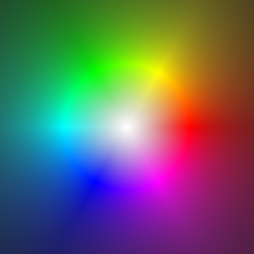
Figure 1
The identical function. Ranges on axes are [−2;2] and [−2i;2i]
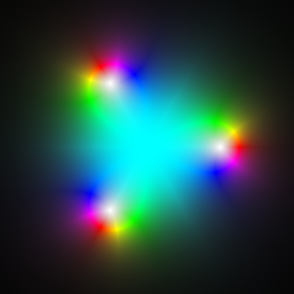
Figure 2
The z³−1 function
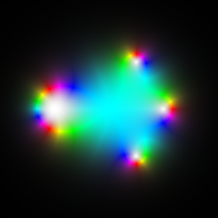
Figure 3
The (z³+1)(z²−1) function

One can easily observe that the graph shows an interesting behavior of the function at the zeros: single zeros have a single color wheel environment and multiple zeros have similar surrounding color wheels, but the colors appear as many times as the multiplicity in that zero occurs (function in Figure 3 has a multiplicity of 2 at −1). This fact can be easily explained by noticing the trivial case of the function f(z)=z^{n}.


Figure 4
The z⁶ function
Elementary functions have beautiful but unusual graphs:

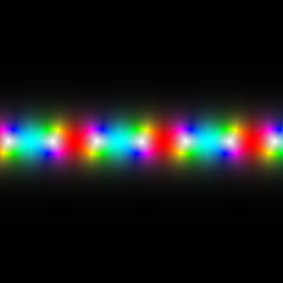
Figure 5. The complex sine function.
Ranges on axes are [−10;10] and [−10i;10i]
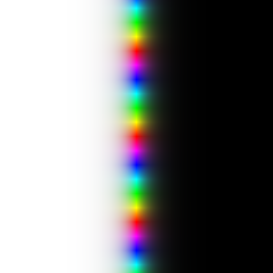
Figure 6. The complex exponential function

3.3 Didactical Arguments for Using Domain Coloring
Our experiences show that aesthetical arguments are enough to give good recommendations for using continuous colorations. The second author had experiments in a series of lectures Introduction to Complex Arithmetic for first grade students at the University of Szeged in April, 2004. This group (20 people) mostly consisted of non-motivated students who are not expertized in computer aided geometry either, but all of them had substantive ideas to find new graphs as new artifacts in the computer room. The third author shows in [14] that domain coloring using the color wheel can assimilate mathematical knowledge for prospective mathematics teachers.
The examples in the previous section show that domain coloring is basically a qualitative method for plotting complex variable functions. A general overview of the behavior of the function can be rapidly summarized with this method. Zeros and their multiplicities and other basic properties like periodicity, symmetry and range can be easily read by the students as well.
In this section, we show some more complicated examples to prove the strength of this domain coloring method in teaching complex analysis.
3.3.1 Holomorphic Functions
Rudin wrote in the Preface of his book [25], that holomorphic functions that are as smooth as they can be. Indeed, domain coloring is an excellent way of emphasizing this adequate smoothness in a graphical way.
Let us consider a non-holomorphic function, f(z)=(Re z Im z)^{1/2}, taken from [27]. Its graph clearly shows that for both axes there is a “deep abyss” and no derivatives exist for any points of the axes.


Figure 7. The f(z)=(Re z Im z)^{1/2} function. Ranges on axes are [−5;5] and [−5i;5i]
In fact, this is a real variable function which can be easily extended to complex variable and which is also not holomorphic:
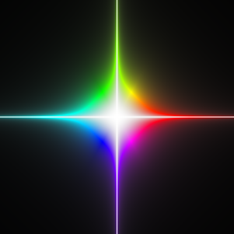
Figure 8. The f(z)=z(Re z Im z)^{1/2} function
3.3.2 Zeros and Singularities
As “opposites” of zeros, a domain colored graph has dark tones near the singularities of the function. Rational functions usually have some zeros and singularities which are isolated. Figure 9 shows a typical example with three zeros and two poles.
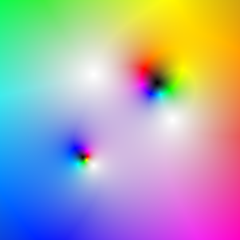
Figure 9. The f(z)=(z³−1)/(3(z²−i)) function.
Ranges on axes are [−2.28;2.28] and [−2.28i;2.28i]
Like holomorphic functions always have their zeros isolated, meromorphic functions also have their poles (and zeros) isolated.
Essential singularities can also be observed very simply. This will be described in details in Section 3.3.5 and Section 5.
3.3.3 Riemann Surfaces
Basic examples of Riemann surfaces are connected with inverse functions of elementary functions. In most cases we have to be cautious because these functions may be multi-valued and a faithful drawing can be achieved by gluing different branches of the functions.
Traditional methods solve this visualization problem with three dimensional plotting. Here we must build a separate picture for every branch. Figure 10 shows the results for the square root function.

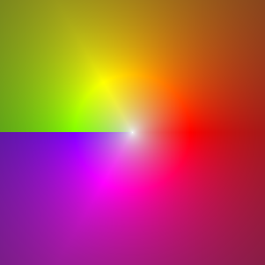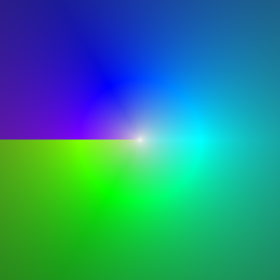
Figure 10. Branches of the square root function
We drew the principal value in the first graph, and then the principal value multiplied by −1 in the second one. At first glance one can observe the branch cut which is the “left half” of the real axis. One may cut the graphs on the branch cuts by using scissors and glue the branches together which will ensure smoothness even on both “left halves” of the real axes.
The same branch cuts can be defined in the case of the multi-value complex logarithm function as well. Here are infinitely many branches. Four of them are shown in Figure 11.
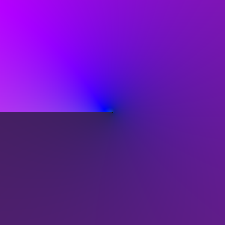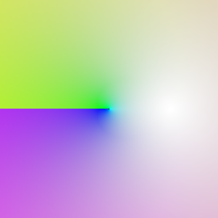
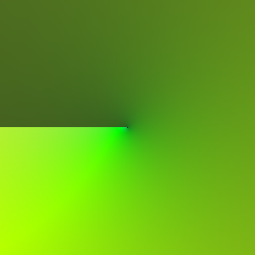
Figure 11. Four consecutive branches of logarithm: log−2πi,
log (the main branch), log+2πi and log+4πi.
All functions are divided by 4 to get better colors.
Ranges on axes are [−1.75;1.75] and [−1.75i;1.75i]
Branch cuts may be more complicated than they are in the previous examples. In Figures 12 and 13 we observe the “real” and “imaginary” circle which are given with the formulas x²+y²=1 and x²+y²=−1 affine equations. The branch cuts are rays (−∞,−1), (1,∞) and (i,i∞),(−i∞,−i), respectively.

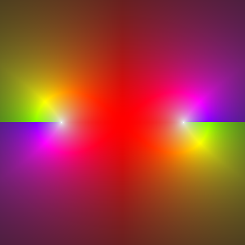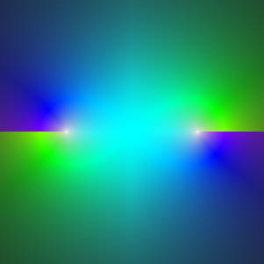
Figure 12. A “real” circle in the complex plane with its two branches,
f(z)= ± (1−z²)^{1/2}. Ranges on axes are [−2;2] and [−2i;2i]
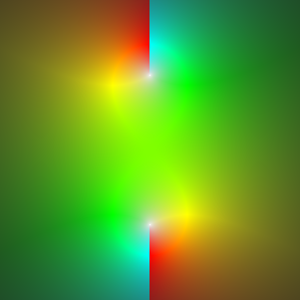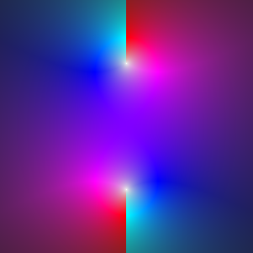
Figure 13. An “imaginary” circle in the complex plane with its two branches,
f(z)= ±i(1+z²)^{1/2}. Ranges on axes are [−2;2] and [−2i;2i]
3.3.4 The Liouville Theorem
Almost all examples above suggest that a typical complex variable function cannot be bounded, because the “dark tone” always appears somewhere. As it is clear from complex analysis, for holomorphic (non-constant) functions this property is always true. As a student experiments with plotting entire functions, it will be experienced soon that for those points which are far enough from the origin, the color is usually dark.
3.3.5 The Picard Theorem
The Picard theorem claims that the range in the neighborhood of any essential singularity is “at least” C\{a} where a is a complex number.
A widely known simple function which has an essential singularity in 0 is sin 1/z. This range is C in the neighborhood of 0. While it is much easier to understand the behavior for real variable, the domain coloring helps us to see that the small copies of the color wheel appear infinitely many times as we zoom into the graph. In Section 5 we will consider a method which offers fast zooming-in for such explanations.

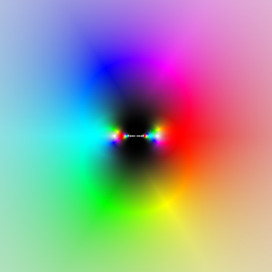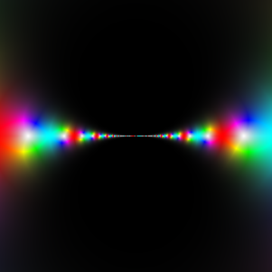
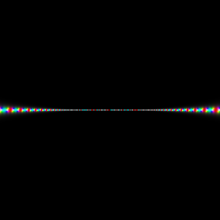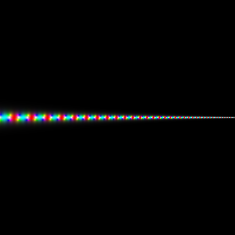
Figure 14
The sin 1/z function with ranges [−2;2] and [−2i;2i],
[−0.2;0.2] and [−0.2i;0.2i], [−0.02;0.02] and [−0.02i;0.02i],
[−0.0093; −0.0029] and [−0.0031i;0.0031i]
4 Why is Visualization Usually Slow? A Study in Code Optimization
Generating domain coloring graphs inside a computer algebra system seems to be a good idea if the most important issue is to write the code quickly. But if the speed of picture generation is more important, then CAS applications may slow down the calculations too much.
Didactic aims for distance learning and guided discovery [36] showed to the second author that an on-line internet version of the domain coloring method should be implemented. After reading the Maple implementation in [14], a similar, freely available Maxima [19] code was written and inserted into WebMathematics Interactive in July 2003.
Unfortunately, this code was able to generate only a 75x75 resolution within a reasonable calculation time which was determined in a maximum of 10 seconds. But this small resolution was inconvenient for further didactic experiments, and these 10 seconds were also too slow in general. This is the reason why the second author decided to speed up the calculations as much as possible.
Benchmarking pointed out that the main reason why CAS-based calculations are so slow is arbitrary precision arithmetic. However, the coloring method is also a slow algorithm even for one pixel. In order to by-pass these problems, the original Maple code had to be rewritten in C language, using floating point arithmetic, the ISO-99 standard GNU C library and the standard complex routines with the “-O3” optimization [11,21,34].
Our benchmarking machine was a Pentium 4 with 2.8 GHz processor. The speedup is about 1200 times faster than the original code. This enables us to support a 300x300 resolution within 1 second response in WebMathematics Interactive.
To make the code even faster, we continued the development in internet independent environment. As we earlier mentioned, the interactive way of a deeper study of essential singularities requires real-time zooming-in methods. The standard movie techniques recommend at least 25 frames per second for a suitable animation which has a need of 2.25 megapixels per second. Using RGB technique and no compression, this can be more than 6 megabytes per second which is yet unavailable for the hardware used by most educated students, even with strong compressions. So assuming low bandwidth, the user should run the movie generator program on her own computer, maybe in Java, Flash or a proper executable file (fitting to her operating system).
One can realize that Java applications usually start slowly on most PCs which make the user feel that Java applications are usually slow [15]. Unfortunately, advanced Flash developer software is not available yet for free which prevents the spread of freely-offered distance learning systems containing advanced Flash code. Consequently our current implementation is a compiled executable written in C and distributed for each operating system as a binary file [13] (the source code is also included).
But with no further optimizations, on a typical client PC (600 MHz, Pentium III) benchmarking reported only 3.45 frames per second. Our aim was to speed up the code as fast as 10 frames per second at least can be guaranteed.
Fortunately, an approximation algorithm was already available for us in [9], which was designed by the first author back in 1997. He did it for his fast rendering real-time fractal zoomer software, XaoS. Using his method currently we can reach 14.28 frames per second for displaying many elementary complex functions on the same architecture.
5 Approximated Real-Time Visualizations
The basic idea behind fast real time animations is to use information already computed in the previous frames instead of re-computing the color of each pixel.
Usually when rendering the function on the screen, individual pixels correspond to a regular rectangular grid dividing up the selected view-port. In our approach we will allow slight departures from this ideal grid in order to allow re-use of already known values (see Figure 20). To conserve memory usage we will consider only data that are present in the immediately preceding frame, and we will require the pixels to form straight rows and columns (Figures 15 and 16), so the real coordinates of individual pixels can be specified via two arrays xmap and ymap specifying real and imaginary coordinates of each pixel. (So a pixel at coordinates (x;y) represent f(xmap[x]+ymap[y]i).)
Figure 15. Grid pixels for the preceding (black pixels) and the current (red pixels) frame. This case is idealized,
because it is assumed that the preceding frame has an equidistant grid which is usually true only for the first frame
Figure 16. Reusing already calculated “black” pixels for most pixels of the current frame (“red” pixels).
The remaining pixels (in magenta) have to be calculated. Green pixels are off the current frame and will not be used anymore
Our algorithm works as follows:
1) Save the pixels from the previous frame together with copy of arrays xmap and ymap (in the arrays xmap' and ymap').
2) Compute new xmap approximating the new view-port, reusing values from xmap' as much as possible.
3) Do the same for ymap.
4) For each pixel whose xmap and ymap values match some old xmap' and ymap', copy the value computed from the previous frame.
5) Compute the remaining pixels which are not covered by Step 4 (see Figures 15 and 16).
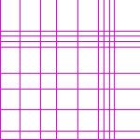
Figure 17. A typical distribution of “red” and “magenta” pixels at a resolution of 75x75. Red pixels are drawn in white
The main complexity lies in Step 2. The quality of approximation is critical both for performance and smoothness of the animation. The author of this method originally experimented with simple algorithms looking for best match in distance lower than the difference between individual pixels. After several iterations of the algorithm the approximations however got considerably uneven and resulted in noticeable artifacts (see Figure 18). Much better results can be obtained by formulating the problem as an optimizational problem maximizing the quality of approximation.
The choice of the objective function (quantifying the quality) should represent the fact that approximations should be as close to the optimal function as possible, they should be as regular as possible (avoid situations where many pixels are close to the optimal values but few are very far off), and avoid introduction of too many new computations. These requirements are obviously contrary to each other and thus choice of the objective function is a kind of an art in balancing individual requirements. After some experimentation, the cost function has been chosen as the sum of costs of the individual approximations map[x] defined as follows:
a) If there exists such an x' that map[x]=map'[x'], the cost is (map'[x']-ideal(x))², where ideal represents the ideal values of each map[x] (for view-port min...max and resolution R computed as min+x∙max/R). In our examples R=300.
b) If the value map[x] represents a new value, the cost is the same as if the approximation were 3 pixels apart ((min−max)/R∙4)².
This simple function appears to produce good results and is cheap to compute. Finally we want to outlaw all approximations that use duplicated values or that are not monotonously growing sequences. This rule helps to simplify the algorithm searching for the minimal cost described below and is a natural requirement for a feasible approximation as well (we do not want to reorder the pixels nor lose any resolution). One can imagine that such outlawed sequences have a cost of infinity or simply they are not taken into consideration.

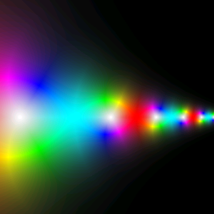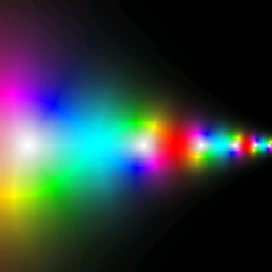

Figure 18. Graphs of the sin 1/z function using brute force (smooth output) and the approximated method (“crinkled” output)
Having the objective function, one can find the optimal matching via a standard dynamic programming [3] technique. We consider the problem of looking for a function i(x) from 1...R to 0...R so that map corresponding to it has the minimal cost. The map corresponding to a given i has map[x]=map'[y] whenever there exists y such as x=i(y), and a new value otherwise. Let us consider i as a function representing the map from the old pixels to the new ones. Observe that the cost of map is the sum of costs of mapping map'[x] to map[i(x)] for all i(x)>0 and ((min−max)/R∙4)² for each i(x)=0.
To find the best possible function i, we use an inductive algorithm. We will inductively compute partial functions i_{l,l'} from 1...l to 0...l' with minimal costs computed the same way as the cost of map corresponding to i described above. Note that i_{R,R} is equivalent to i.
Computing i_{1,l'} is trivial. One can try all possible values for i_{1,l'(1)} and compute their costs choosing the minimal one.
Figure 19. The map[] and the map'[] arrays
Computing i_{l,l'}, when functions i_{m,m'} for m<l and m'≤l' are known, is easy too. One can try all possible values of i_{l,l'(l)}. Having i_{l,l'(l)}=x fixed, the first l−1 values of the function can be taken from i_{l−1,(x−1)(l)} for x>0 and i_{l−1,x(l)}. We can also re-use the already computed costs of the function we took initial segment from increasing it by cost of mapping map'[l] to map[x]. I.e., the cost of i_{l,l'(l)} produced above can be computed from the already computed cost of i_{l−1,(x−1)(l)} for x>0 or i_{l−1,x(l)} by adding the cost of mapping map'[l] to map[x].
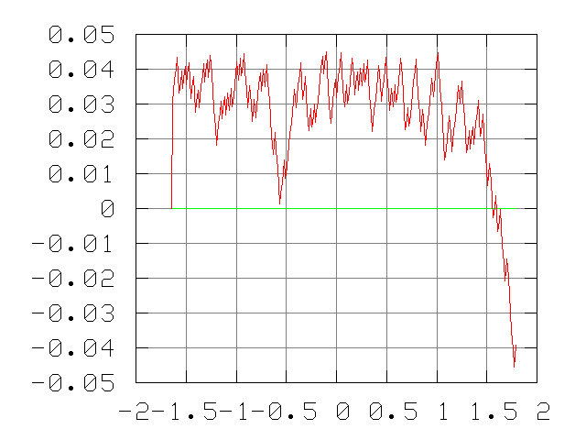
Figure 20. A typical departure diagram for map[] comparing to the ideal grid
Such an internal loop will run in O(l') time. It is possible however to reduce this time to O(1). Let us observe that mapping map[l] to x is cheaper than computing a new value for 8 different choices of x, at the most, given by the choice of the cost function (Rule b). It is possible to look up those affordable values of x by remembering the affordable values from the previous iteration of the algorithm. Searching forward for the costs from this starting point will amortize to the cost of O(1).
This simple inductive algorithm will compute all i_{l,l'} for l, l<R each in time O(R) resulting in O(R²) running time – too much for a practical implementation. Since for fixed l not all i_{l,l'} will be used in the future iterations of the algorithm; only those values, allowing continuation to the 8 nearest values and one extra for allowing new computation, will be used. By avoiding computation of those unused values we can reduce running time to O(R) algorithm – fast enough for practical use.
To finish the construction of map, we need to fill in the missing gaps where i(x)=0. The original implementation of the algorithm simply set these values to ideal(x). This however lead to irregularities in the distribution (in many cases the pixel ends up very close to its left or right neighbor). So the final implementation searches for continuous sequences of new values, looks for the already known values on the left and right of the sequence and divide the interval regularly.
Having map computed, the remaining steps are straight forward. For a well performed implementation it is necessary to copy the old pixels in the CPU memory cache a friendly way (process all lines at the same time) and act similarly when computing the new values.
Two freely available computer programs show this technique in praxis in [10] and [13].
6 Afterword
Today's experiences show that real-time visualizations make teaching of mathematics much more interesting. The documentary movie on the television about The Power of Chaos [2] caused world-wide responses not only among the mathematicians but students too. It also deals with (pregenerated) fractal animations.
There are other attempts to show mathematical creatures using real-time techniques, e.g. graph explorers written in Java for free use, as an internet service [1,5]. XaoS algorithm also exists implemented in Java in [23], however this program seems to be about 2.5 times slower than the C code.
Some experts say that modern computers will mostly run internet applications in the future, however others claim that the users will always need a stable and fast underlying operating system to work with many software installed on it. From the teacher's view, the most important thing is the ease of use. Nowadays the internet access is available for most students in a quite high bandwidth in schools as well. Free non-internet software is also a reasonable choice for everybody, e.g. in downloadable ISO-formats [16]. Technique is already good enough for almost everyone to study mathematics who really wants it.
7 Acknowledgements
Michael Trott kindly provided us his exhaustive Mathematica notebook: Visualization of Riemann Surfaces: Composition of Elementary Transcendental Functions.
The authors would also like to thank János Karsai, Gyula Horváth, Hans Lundmark, Markku Rontu, Paulo Gustavo Soares Fonseca and Barbara Fülöp for their kind support.
Bibliography
[1] Bakos, G. (2003): Function plotter, http://www.stud.u–szeged.hu/Bakos.Gabor.1/fp
[2] Barlow D.; Cowan R. (2003): The Wonders of Science – Programme One: The Power of Chaos, 52', Inca Productions, London
[3] Bellman, R. (1957): Dynamic Programming, Princeton University Press, Princeton, New Jersey
[4] Borwein, J. M.; Corless, R. M. (1999): Emerging Tools for Experimental Mathematics. – In: The American Mathematical Monthly, 106, p. 889-909
[5] Cooper, A. (1997): Graph Explorer, http://www.langara.bc.ca/~acooper/GeX/v2/Grapher-p4j.htm
[6] Corless, R. M.; Jeffrey, D. J. (1998): Graphing elementary Riemann surfaces. – In: ACM SIGSAM Bulletin, 32 (1), p. 11-17
[7] Farris, F. A. (1997): Visualizing Complex-valued Functions in the Plane. http://www.maa.org/pubs/amm_complements/complex.html
[8] Griffiths, P. A. (1989): Introduction to Algebraic Curves, volume 76 of Translations of Mathematical Monographs. American Mathematical Society.
[9] Hubička, J. (1997): XaoS 3.1. A Fast Real-time Fractal Zoomer – Hacker's Guide, http://xaos.sf.net/xaosdev.dvi
[10] Hubička, J.; Marsh, T.; Kovács, Z. et al. (2003): XaoS. A Fast Portable Real-Time Interactive Fractal Zoomer, http://xaos.sf.net
[11] (1985) 754-1985 IEEE Standard for Binary Floating-Point Arithmetic
[12] Kovács, Z. (2002): The World of Fractals. – In: Matematika tanári kincsestár, Raabe, Budapest (in Hungarian)
[13] Kovács, Z. (2004): Real-time Zooming on the Complex Plane, http://www.math.u–szeged.hu/complex_plot
[14] Kovács, Z.; Kozma, L. (2003): Assimilation of Mathematical Knowledge Using Maple. – In: Teaching Mathematics and Computer Science 1 (2), p. 321-331
[15] Lewis, J. P.; Neumann, U. (2004): Performance of Java versus C++. http://www.idiom.com/~zilla/Computer/javaCbenchmark.html
[16] (2004) http://www.linuxiso.org
[17] Lundmark, H. (2000): Visualizing Complex Analytic Functions Using Domain Coloring. http://www.mai.liu.se/~halun/complex/domain_coloring–symbol.html
[18] Mandelbrot, B. (1982): The Fractal Geometry of Nature, W. H. Freeman & Co.
[19] (2004) http://maxima.sf.net
[20] Needham, T. (1997): Visual Complex Analysis. The Clarendon Press, Oxford University Press, New York
[21] Overton, M. L. (2001): Numerical Computing with IEEE Floating Point Arithmetic, SIAM, Philadelphia, Pennsylvania
[22] Peitgen H. O.; Richter, P. (1986): The Beauty of Fractals, Springer-Verlag
[23] Rontu, M.: Real-time Fractal Zooming. http://www.hut.fi/~mrontu/papers/zooming/fractal.html
[24] Roseman, D. (1998): Exploring Low Dimensional Objects in High Dimensional Spaces. – In: Hege, H. C.; Polthiers, K. (Eds.), Mathematical Visualization, Algorithms, Applications and Numerics, Springer-Verlag, p. 281-291
[25] Rudin, W. (1986): Real and Complex Analysis. McGraw-Hill
[26] Santa Cruz S.; Fonseca, P. S. (1998): Bombelli. A Java Complex Function Viewer. http://www.dmat.ufpe.br/~pgsf/bombelli
[27] Szőkefalvi-Nagy, Gy. (1995): Complex Analysis, Nemzeti Tankönyvkiadó, Budapest (in Hungarian)
[28] Thaller, B. (1997): Visualization of Complex-valued Functions. http://www.kfunigraz.ac.at/imawww/thaller/visualization/complex.html
[29] Thaller, B. (1998): Visualization of Complex Functions. – In: The Mathematica Journal 7 (2)
[30] Thaller, B. (1998): Visual Quantum Mechanics – Selected Topics with computer generated movies of quantum mechanical phenomena. Book/CD combination, Springer-Verlag, TELOS
[31] Thaller, B. (2004): Advanced Visual Quantum Mechanics – Atomic Physics, Quantum Information, Relativistic Quantum Mechanics, to appear, Springer-Verlag
[32] The Free Software Foundation (2001): The GNU C Library Reference Manual, Edition 0.10, http://www.gnu.org/software/libc/manual/html_node
[33] The Stone Soup Group (1988): Fractint. http://www.fractint.org
[34] Trott, M. (1997): Visualization of Riemann Surfaces of Algebraic Functions. – In: Mathematica in education and research, 6 (4), p. 15-36
[35] Trott, M. (1999): Visualization of Riemann surfaces. – In: Sixth SIAM Conference on Geometric Design, http://library.wolfram.com/examples/riemannsurface/notebooks.html
[36] Vajda, R.; Kovács, Z. (2003): Interactive Web Portals in Mathematics. – In: Teaching Mathematics and Computer Science 1 (2), p. 347-361
[37] Vajda, R.; Kovács, Z. et al. (2002): WebMathematics Interactive. http://wmi.sf.net

Addresses
Hubička, J., Charles University, Dep. of Applied Mathematics, Prague, Czech Republic.
Email: hubicka@kam.mff.cuni.cz
Kovács, Zoltán, University of Szeged, Bolyai Institute, Dep. of Analysis, Szeged, Hungary.
Email: kovzol@math.u-szeged.hu
Kovács, Zoltán, College of Nyíregyháza, Institute of Mathematics and Computer Science, Nyíregyháza, Hungary. Email: kovacsz@nyf.hu

